NAAN MUDHALVAN ASSIGNMENT

**NAME:** ESAKKI RAJA S

**DEPARTMENT:** COMPUTER SCIENCE AND ENGINEERING

**COLLEGE:** DHANALAKSHMI SRINIVASAN INSTITUTE OF TECHNOLOGY

**NAAN MUDHALVAN COURSE:** DIGITAL MARKETING

**NM ID:7F628DE747D5C4396DE4C59E39B4D27C**

**ASSINGMENT 1:**

Create a blog or website using blogspot and wordpress. Customize the theme design and post new article lwith 500 words

URL:l<https://asgard-teas.blogspot.com/2023/08/asgard-tea-benifits.html>

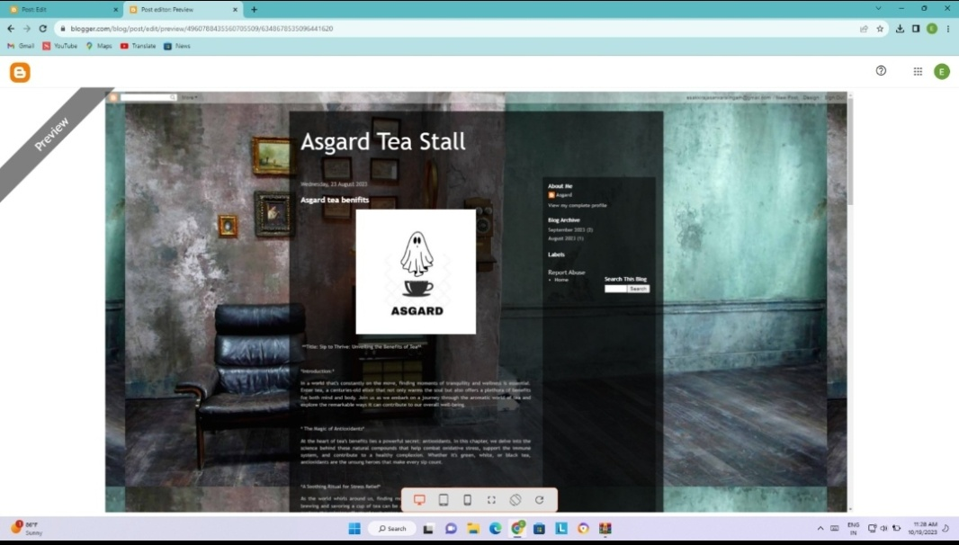

**ASSINGMENT 2:**

Create a new Facebook business page and post one social media poster for your brand

URL:<https://www.facebook.com/dolphin.aqu?mibextid=ZbWKwL>L

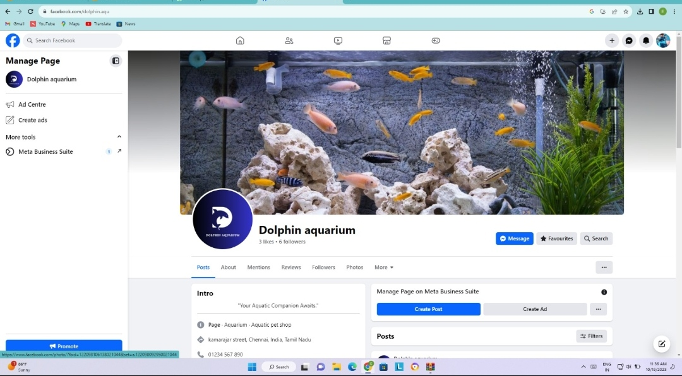

**ASSIGNMENT 3:**

Create and design a advertisement poster using canva.

**URL:**[**https://asgard-teas.blogspot.com/2023/09/infographics.html**](https://asgard-teas.blogspot.com/2023/09/infographics.html)

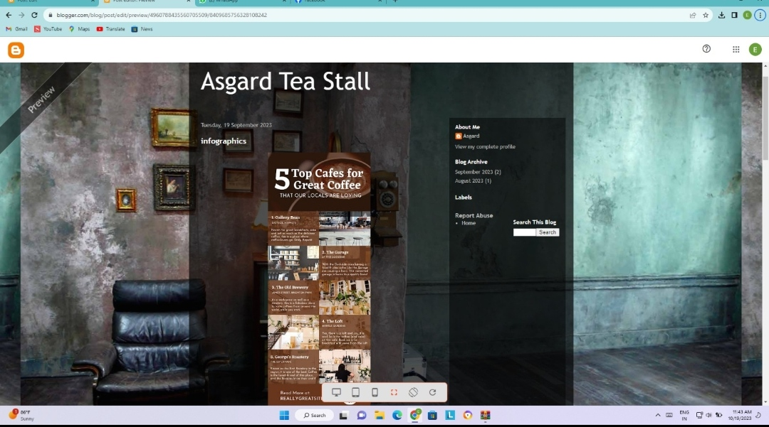

**ASSIGNMENT 4:**

Create an Email newsletter design using Mailchimp or Canva tool

**URL:**[**https://asgard-teas.blogspot.com/2023/09/email-newsletter.html**](https://asgard-teas.blogspot.com/2023/09/email-newsletter.html)

